3.8.2023, Pezinok

**New registrations for protection of designs.**

Three new product designs from upcycled materials under the auspices of EUIPO.

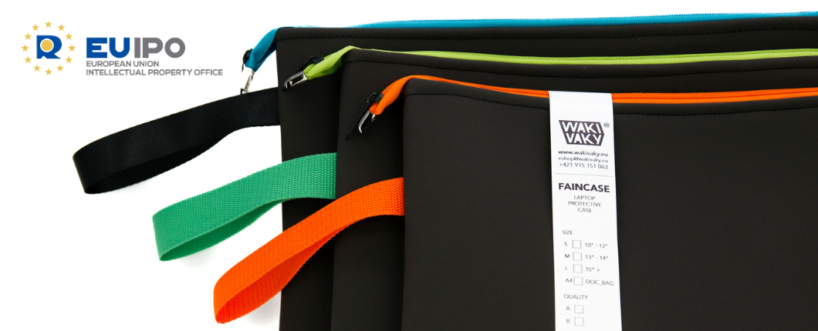

New WAKIVAKY brand products are being developed in the R&D studio in Pezinok. The development team produces proposals all year round, which are further assessed, modified and tested in practice.

We register the best product designs that pass the tests through the European EUIPO office. Most recently we managed to register the following three designs:

* EU design for the product **"HACHAI, HACHAI Sitting Bag"**  n. [015023121](https://www.wakivaky.eu/data/015023121-0001.pdf)
* EU design for the product **"FAINCASE, Laptop/Notebook Case"** n. [015023120](https://www.wakivaky.eu/data/015023120-0001.pdf)
* EU design for the product **"FAINBAG, TOTE Bag Jaguar"** n. [015023120](https://www.wakivaky.eu/data/015023120-0002.pdf)

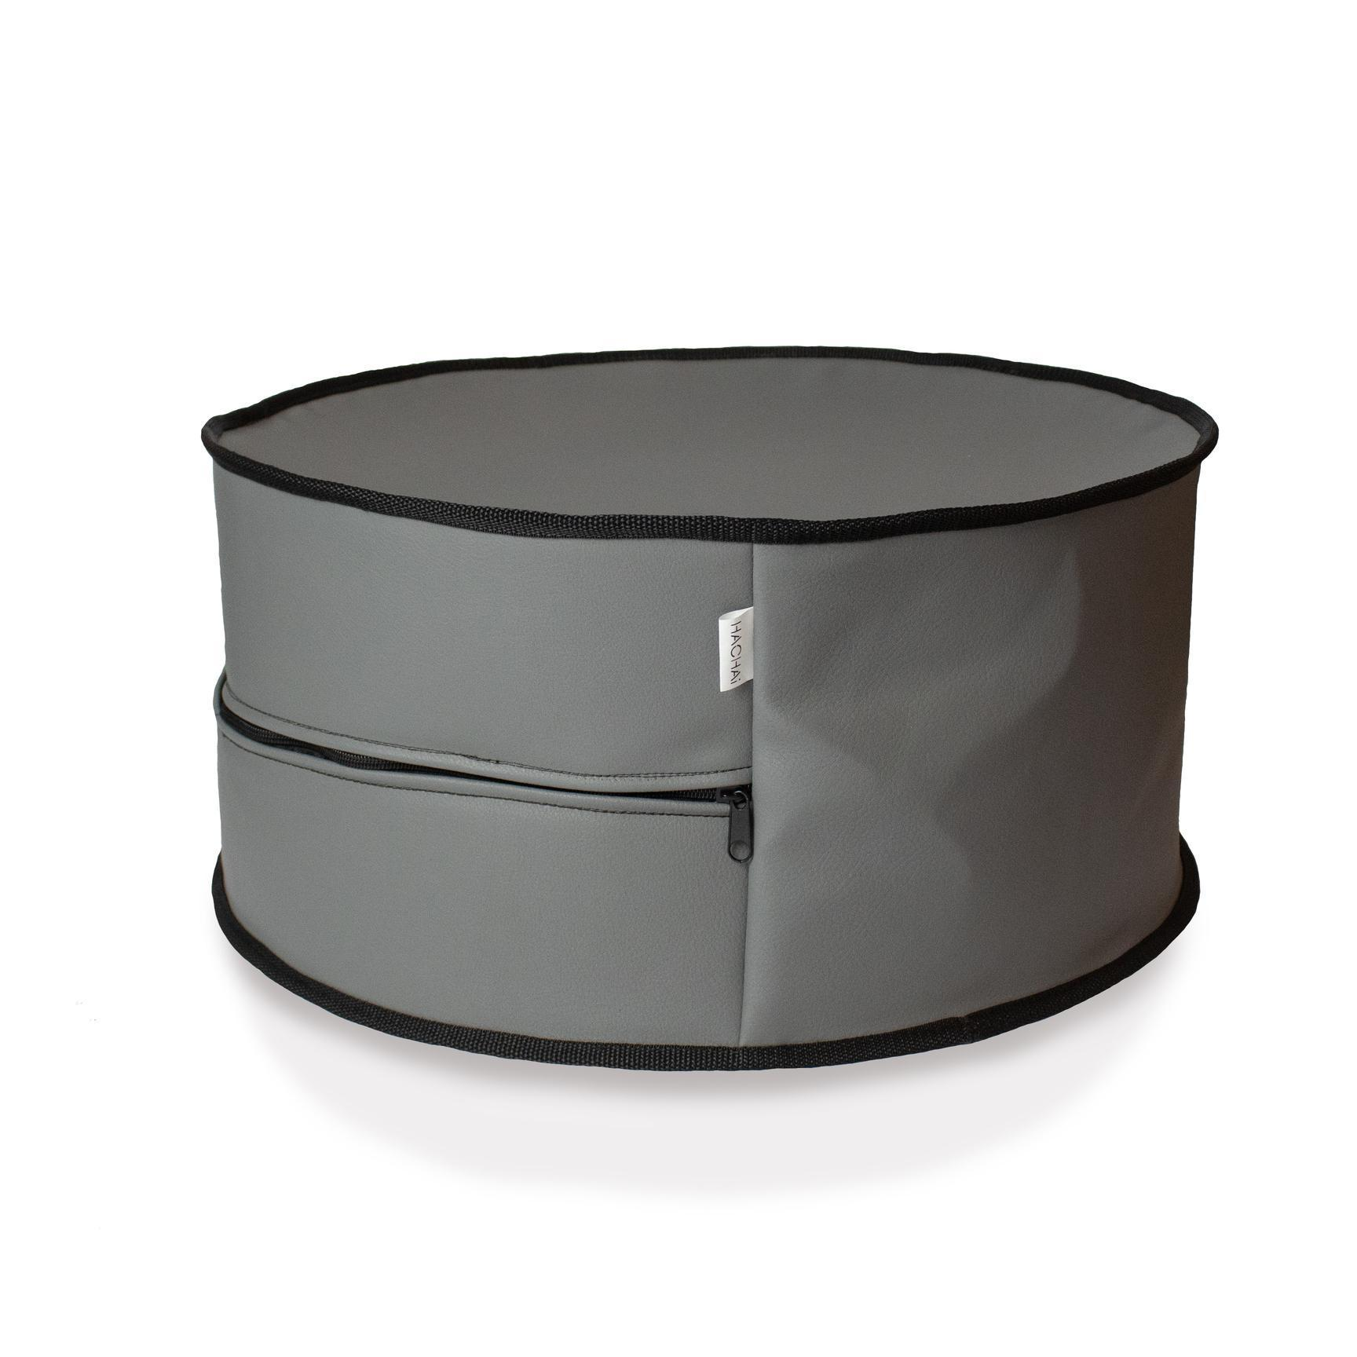 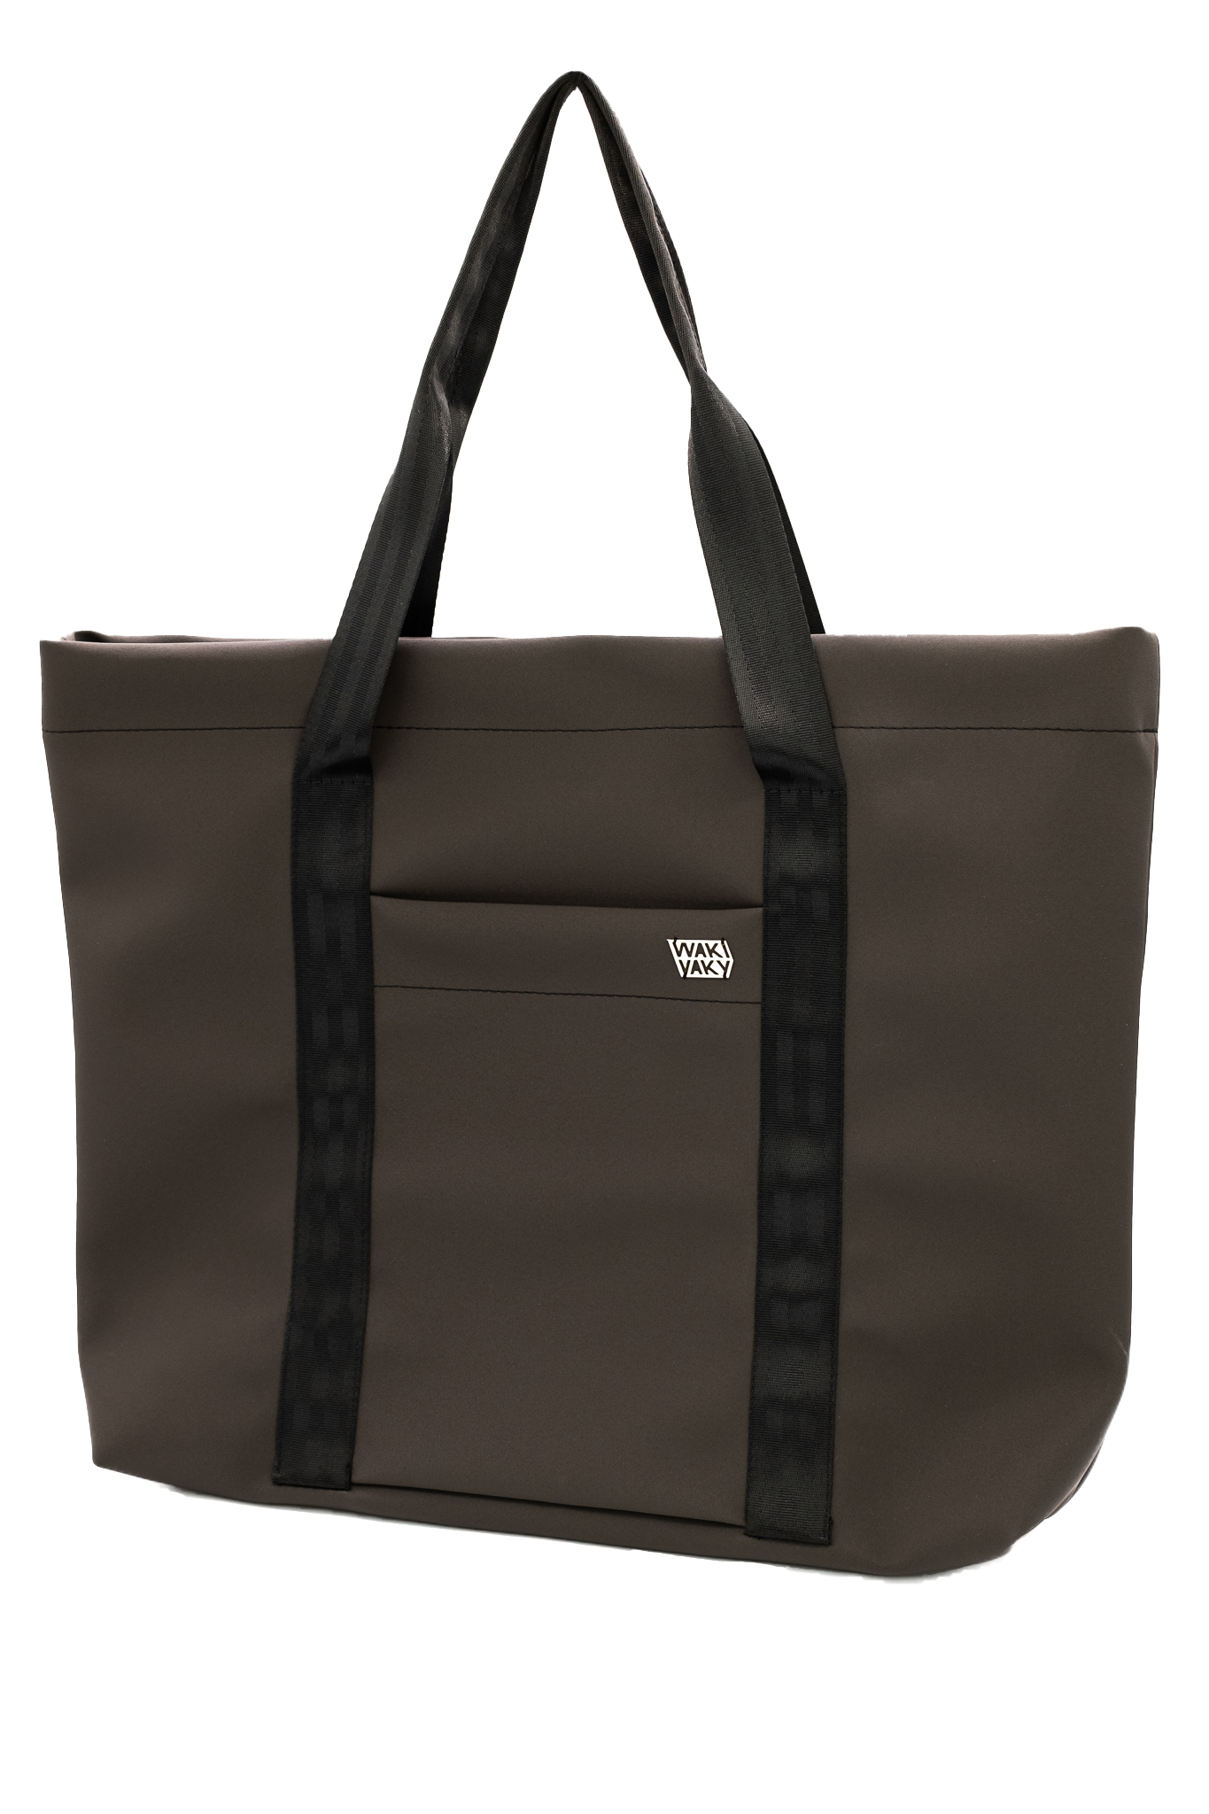 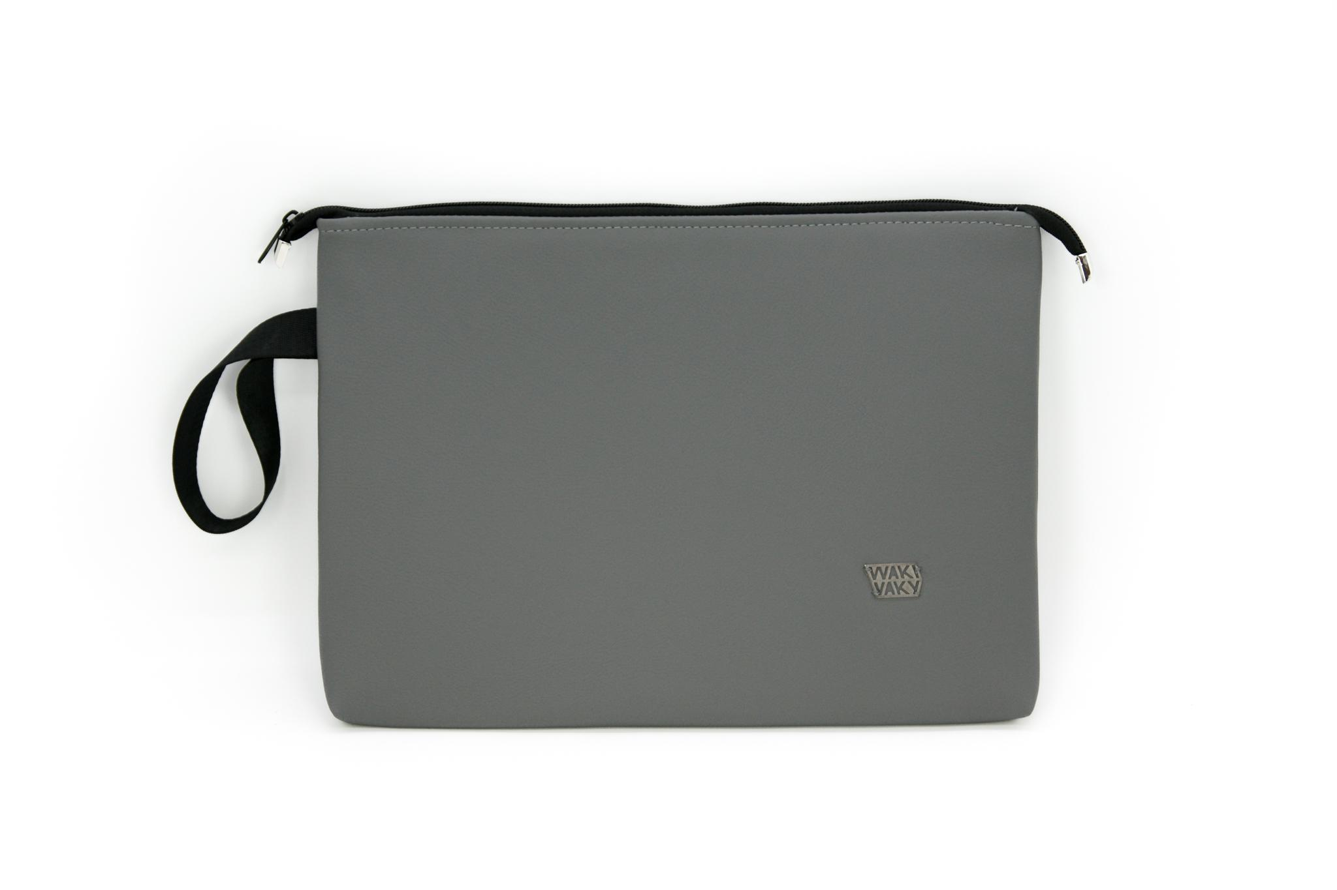

HACHAI Sitting Bag FAINBAG TOTE Bag Jaguar FAINCASE Laptop/Notebook Case