11.9.2023, Pezinok

**New registrations in the FAINBAG product line**

We are continuing with the registration of product designs through EUIPO. We currently have 3 new registrations for designs from the FAINBAG product line.



The ideas that arise in the WAKIVAKY studio have different shapes and sizes. Innovative design is an important business asset for us. That is why we protect the designs of our products through the EUIPO (European Union Intellectual Property Office).

We divide our upcycled products into three product lines - HACHAI, FAINCASE and FAINBAG. The third group of products covers various types of backpacks, bags and backpacks. Aktuám managed to register three more designs from this group:

* EU design for the product **"FAINBAG, Backpack Roll"** [015030228-0002](https://euipo.europa.eu/eSearch/#details/designs/015030228-0002)
* EU design for the product **"FAINBAG, Backpack Cross"** [015030228-0003](https://euipo.europa.eu/eSearch/#details/designs/015030228-0003)
* EU design for the product **"FAINBAG, Backpack Mini"** [015030228-0001](https://euipo.europa.eu/eSearch/#details/designs/015030228-0001)

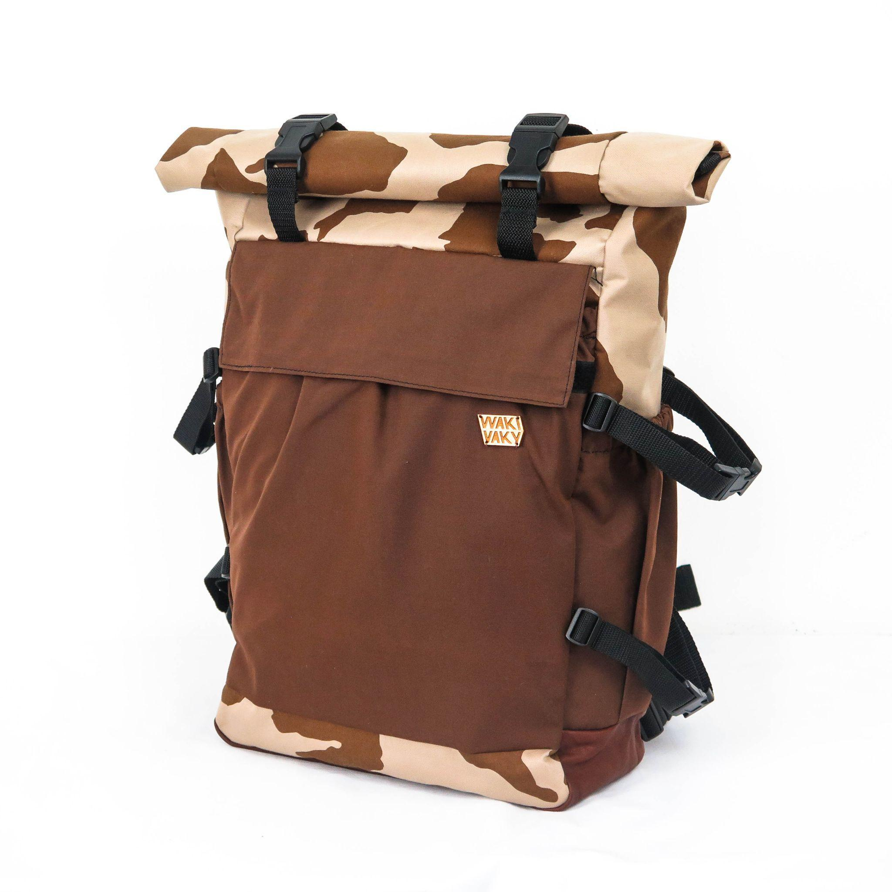 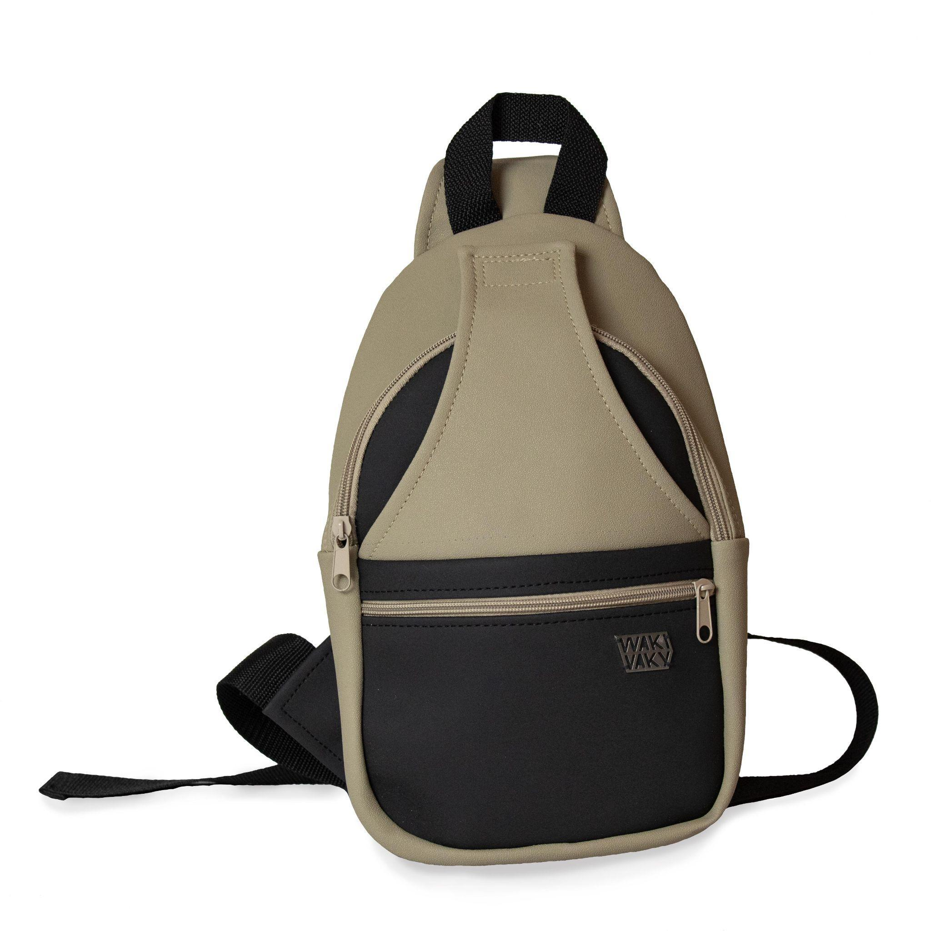 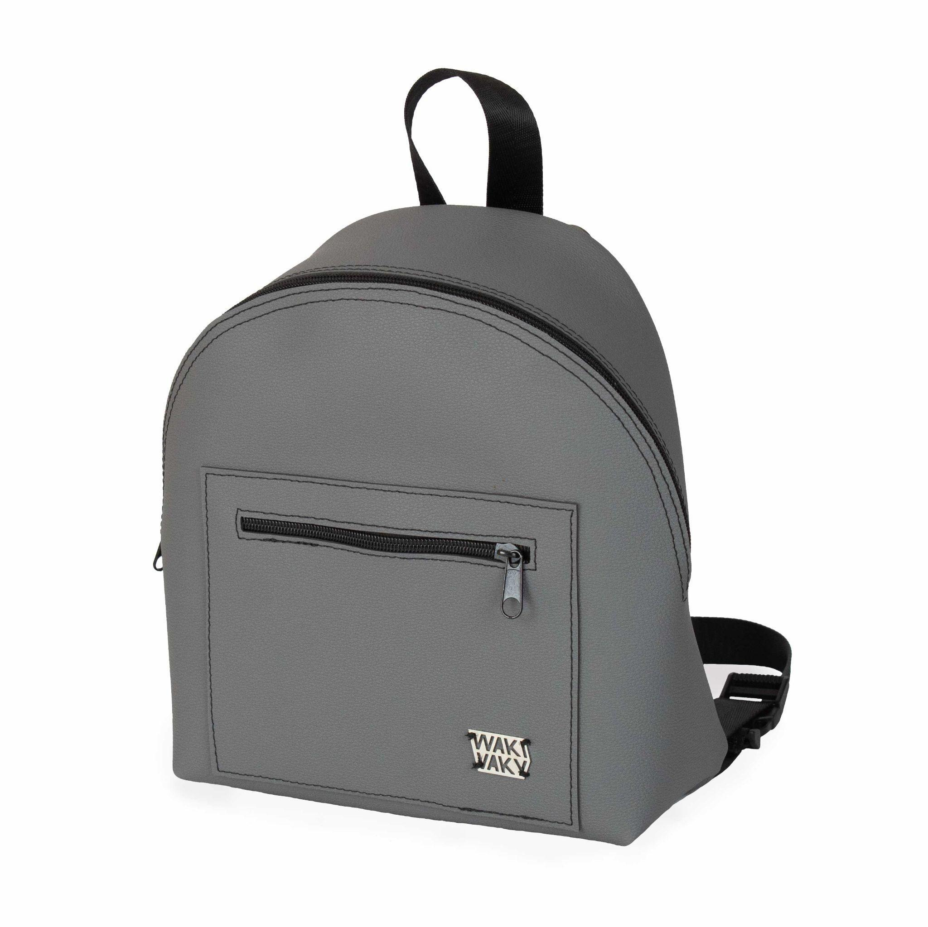

FAINBAG Backpack Roll FAINBAG Backpack Cross FAINBAG Backpack Mini