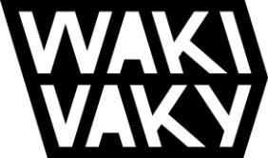

4.7.2023, Pezinok

Products from advertising banners

Unused banners do not have to end up in the trash. We make HACHAI beanbags, bags, or other practical products from them.
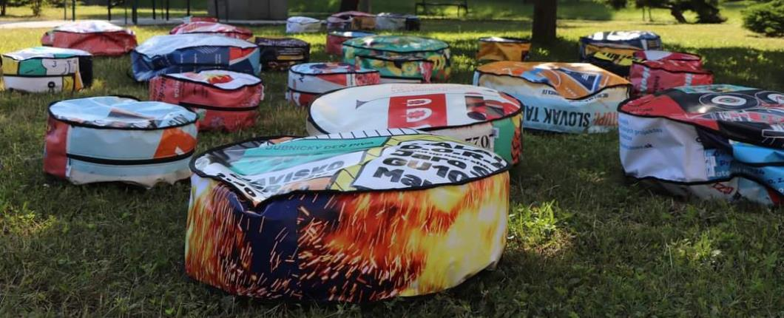

Many companies, as well as cities and municipalities, have advertising banners that they can no longer use due to outdated content and visuals. However, we at WAKIVAKY have found a use for them. From discarded banners, we make products such as bags, wallets, neck pouches, HACHAI seat bags and more. The advantage of these products is the durability of the material and the authentic design - the graphics on the banner also form the visual of the product.

Several people have already tried this upcycling and processing of waste materials in practice. The city of Dubnica nad Váhom, Považská Bystrica, the Pohoda festival, Uprising and others, which are no strangers to sustainability, responsibility and circularity, already have their own banner products. Join them.

TA3 report on the production of beanbags.

---

This project is supported by Norway through Norwegian grants.

Co-financed from the state budget of the Slovak Republic.

dominika@wakivaky.eu
+421-915-151-013
www.wakivaky.eu | 1

