31.7.2023, Pezinok

**We received the ISO 9001 - Quality Management System certificate**

In terms of quality, our processes are up to the standard required by the market.



**The satisfaction of our customers is an important indicator for us.** On the basis of the ISO 9001 certificate, customers know that they are doing business with a company that knows its main business processes, knows how to identify opportunities and prevent potential risks. Our trading, development and production are under constant control and in accordance with international standards.

ISO certification, which we received based on the audit, brings to our company:

* increasing credibility,
* increasing competitiveness,
* optimization and systematic management processes,
* increasing the value of the organization,

and many other benefits.

Despite the fact that we are still a startup, our standards are set correctly. The certificate was issued to us by an accredited certification body - System certifications s. r. o. about. - under the auspices of the worldwide association International Accreditation Forum (IAF).

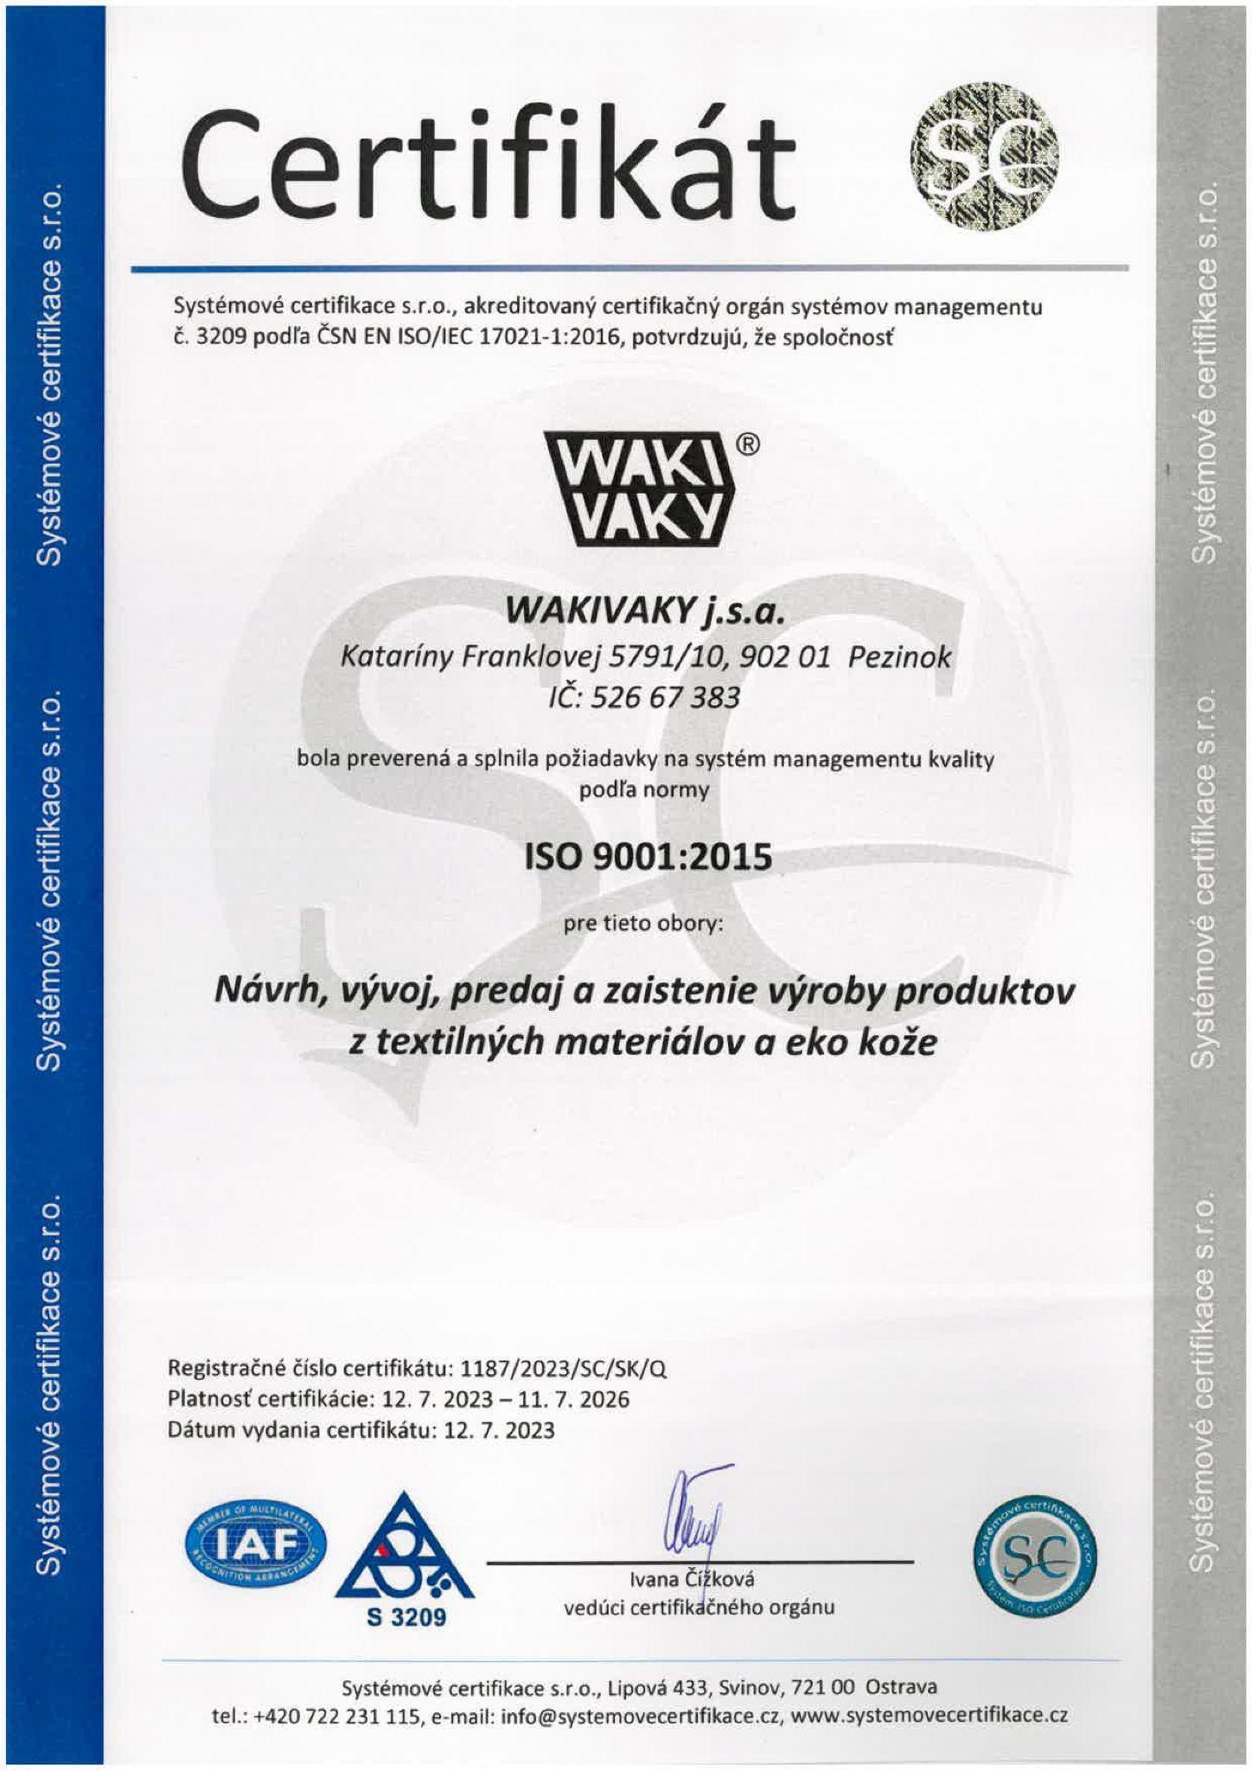

Certificate ISO 9001:2015 - Quality management system for design, development, sales and production assurance of products from textile materials and eco leather.